Student’s name | Viewpoint chosen | Tell the events from the perspective chosen (max 120 words); you can focus on a single event if you prefer. | What puzzles you? What would you like to know? | Paste here a significant picture.
Matteo XXXXX | Darkness | I don’t like my role, I would like to be in the role of my brother, the light. When i have to come everything get so boring, everyone go to sleep and there’s nothing to do or to watch. But since a few days a monster, as human call him, started making everything more interesting, he goes around the city of that strange king Hrothgar and kill all his powerful soldier. Now I have something to watch. | The problem is that tonight grendel didn't come and everybody is sleeping in the Hart Hall again. I wonder what happened? | 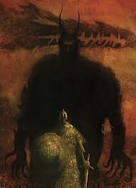
Fabio XXXXX | The Dragon | I was guarding the treasure in my cave when a human stole a cup from it.  I was furious so that I got out of the cave and I started burning everything, until the king of that kingdom named Beowulf and one of his mates started fighting me.  After a long and brutal battle I have seriously injured him, but when I started thinking I had won, he found the strength to deliver the death blow.  So I slowly started falling down and I wasn’t understanding nothing about the situation except that I had not been able to do my job guarding the treasure. | Now I just want to know why that human stole part of my treasure, but most importantly I want to know if that man called Beowulf was a normal human or something more. | 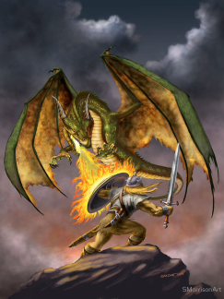
Caterina XXXXX | The Coast Guard | I am fulfilling my duty as guardian of the coast when, all of a sudden, I see the sun gleams upon some weapons coming from a foreign ship. I quickly mount my horse and, waving my huge spear, I go towards the warriors. I am stunned by them: I have never seen before any foe coming armed as them and at the same time I have never met such noble warrior as their leader seems to be. I immediately ask them what is the purpose of their visit, reminding them proudly that I have always protected the sea-cliffs and I will never let foe in, but the answer of their leader makes me realize they are friends coming in help of my king. Is Beowulf the name of the noble thane. | After bringing them to my king I have to go back guarding the coast, but I will never forget the image of that thane: will he be up to the task? | 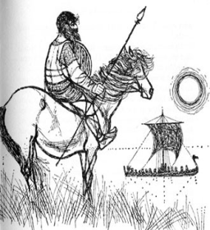
Pietro XXXXX | Grendel's mother | Me and my son used to live peacefully in our own, but he had been hating the people's ceremonies for too much time and he decided to act. I knew he was strong enough to beat every soldier that he could meet, and that's what happened. Every night he used to overwhelm the Hart Hall in order to terrorize the population. After a few years, Grendel went out for another attack, and he never came back. I found him in our lake without an arm. I decided to revenge my son, so i followed his last steps when I finally found the famous Hart Hall. When I was back home suddenly a strong man came in my cave, I remember he took my son's sword, then I can't remember nothing. | I wonder who this legendary soldier was, he wasn't a normal human, he had something that the other didn't. I wonder how did he killed my son, how he killed me and, finally, how a human can be so strong and brave in combat. | 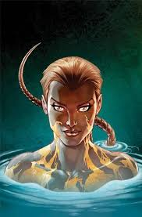
Niccolò XXXXX | Grendel | I hate human’s ceremonies; I hate joy and happiness. For these reasons, I have been attacking and killing humans in the Hart Hall for 12 years. In these years no man has ever defeated me. On the other hand I can’t touch the king’s throne, I don’t know why. Now it’s night, so I have to go to the Hart Hall and do my job. Tonight it’s different from the others; in the Hall there’s a man without armor and weapons who’s waiting for me. He is surely a fool! No problem I will kill him as I did with the others. The battle is started and he is winning, how is that possible? He cut my arm off, let me escape. I don’t think I will survive; I'll throw myself into the lake in honor of my mother. | I want to know why I cannot touch the Throne. In addition to that, I want to know the name of the warrior who defeated me and I wonder if that warrior was a common human or has something like superpowers. | 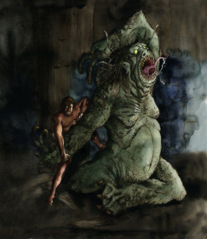
Zaccaria XXXXX | The treasure | I have been sleeping in a cave for centuries. There was a dragon defending me. With his fire he used to keep me warm during the winter and with him I was never alone. No one could steal and scatter me. Then a cruel slave came and took a cup, everytime someone split me in parts I feel like someone break one of my big hands. I was suffering so much that my pain woke up the dragon. My protector is the only one that understand my needs. I said him that a slave had stolen a cup and he got so angry with that disgusting man that he immediately went out of the cave to kill him. | I wonder what happened to my dragon. He didn’t came back and I’m really worried about what could have happened to him.
Nicole XXXXX | Sword forged by Giants | I have been in this same cave for hundreds of years. Soon after I was forged by the Giants, that witch stole me and hid me here. Today something seems strange. The she-devil is fighting with a man. Please! Look at me! You can use me to slay that witch! […] See? Without me you would have died! I can finally be useful again! Now please, let me see the light of the day again! If you take me as your sword, I won’t fail you. What are you doing? No! Don’t use me to severe the head of that monster: there’s venom in his blood! Stop! I’ll melt! […] Why didn’t you listen? I’m just a useless hilt now. | I wonder who that man was and whether he would have kept me as his sword if I hadn’t been ruined. What will become of me once I am given to his king? | 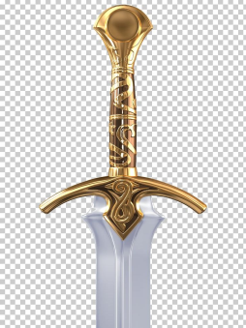
Elisa XXXXX | Hart hall | Once I was the most important building in the whole country. Warriors used to sleep inside me because they felt safe, and I was so proud of me. No one could pass my defense, and my king was satisfied. Until an enormous evil monster, in a night, decided to put an end to all joy by entering into me and killing my people. I was heartbroken, looking at that massacre without being able to do anything to help. For years no one came any more, I felt so lonely that even my beauty has suffered, I no longer shone like it used to. But luckily one day I see him enter from my door: Beowulf, the strongest man I have ever seen, decided to save me and my folk. And so he did, after twelve years of terror on the part of Grendel, the terrible monster, Beowulf arrived and killed it, restoring peace in the population. Since then, every night the warriors celebrate and sleep in my room, as they once did. | I’d like to know what happened at the Hart hall after the death of Grendel when Beowulf has returned to his home. Mostly if the building and its folk had other problems. | 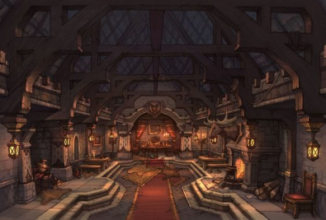
Gaia XXXXX | Wiglaf | I am the most important of king Beowulf’s thanes and he chose me with other 10 brave men to defeat a terrible dragon that is haunting his kingdom.  The battle had started, I see that he is in trouble and I’m encouraging the other warriors to go and help him but they are too coward. So, I’m joining in the battle to defeat the dragon. We killed it! However, Beowulf is mortally wounded he is telling me that we should build a great mound and the dragon’s treasure should be buried with him.  Now that I am the king of the Goths I’ll have a huge mound built on the coast so people can see it from the sea. | I wonder what would have happened if the other warriors had the courage to fight the dragon. | 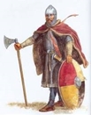
Sara XXXXX | The slave who steals the cup from the treasure | I am actually escaping from my life. I won’t be a slave anymore! There is a cave here from which a very deep noise is coming out. I look inside and I am too scared... never seen such an enormous creature! It is a huge and dangerous dragon! I try to get closer and I see something sparkling near the monster… it is a wonderful treasure! It should definitly have a big value ! If I steal something I will surely become a rich man and I will be estimated by everyone, like my Lord Beowulf is. I will take that gold cup and I will run away. It is the key for my success. | I have now taken the cup from the treasure. Will the dragon notice my theft? | 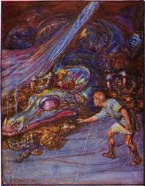
Rebecca XXXXX | Wealtheow | Today Beowulf, one of Hygelac’s Thanes, proved strength and bravery slaying once and for all the dreadful and evil ogre Grendel, who has caused pain for 12 long years. Beowulf was able to kill him only with his bare hands and his mind. At the beginning I was sceptic about his power, I asked myself: “What is the reason why a man who comes from Gothland crosses the sea to defeat a monster risking his own life? Is he tricking us?”. Even though loads of questions were worrying me, my husband and I had no chances except trusting him since Grendel was becoming more and more cruel. Now I am about to go to the Hart Hall to celebrate Beowulf’s victory, during the banquet I am going to give him a mantle and a collar. | I wonder if peace can last forever. How can I be sure that our enemies have been completely defeated? Is there, in the moor, any other creature which can disturb our joy? | 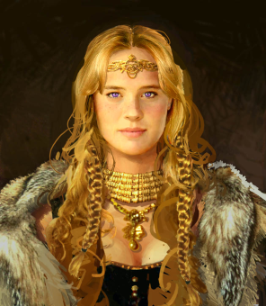
Filippo XXXXX | Beowulf | I’m the greatest and bravest of all the Geats, I come from overseas, in the northern part of Europe.  I have fought and won with all the evil creatures that I met and now it’s time that I Come and help you defeating your monsters. It will be hard and I will need all the courage I have, but in the end I will defeat grendel the ogre ,also if he has the hardest of all the armours. With him I will take down also his mother and her malefic spells. I also know that my last fight will be the one against the evil dragon, where all my knights except one will betray me during the moment of most need. | I only want to know what could be different if only my closest friend and trusted knights didn’t betray me. Would my story be different? | 